CSC424 Database Application Design Document Template

Project Name: Prison System Management

Project Team Members: Christopher Fajardo

Creation Date: 5/15 to 5/19

Revision History:

This document is a template of design document designed for CSC424, Spring 2015.[1]

**1. Introduction**

This is a design document made by Christopher Fajardo explains a system that management a prison , elements within this system includes the input and output of information of inmates also it includes information of the staff , members. Also this system provides a login and logout as securities

**2. Architecture Design**

Database was coded in MySQL (SQL)

Application was coded in Visual Studio (VISUAL BASIC)

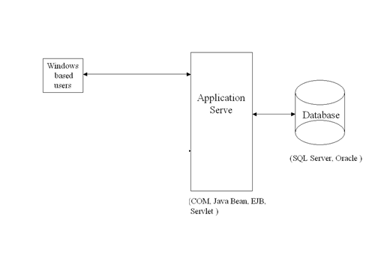

**3. Database Design**

The database design specifies how the date used by the software is going to be stored.

**3.1 Entity-Relationship Diagram** **– Business Data Model**

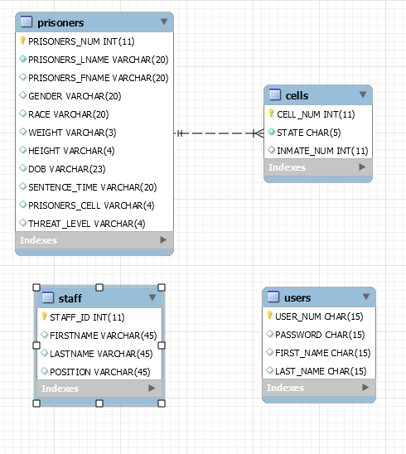.

**3.2 Relational Data Model**

*Prisoners(prisoners_num,prisoners_lname,prisonersfname,gender,race,weight,height,dob,sentence_time,prisoners_cell,threat_level)*

*Cells(cell_num,state,inmate_num)*

*Staff(staff_id,firstname,lastname,position)*

*Users(user_num,password,first_name,last_name)*

# 3.3 Logical Schemas

The complete (compilable) set of CREATE TABLE statements (and other SQL statements) that declare the database schema, including integrity constraints, domain specifications, assertions, and access privileges -- documented in a template with the intended use of each table and column.

|  |  |  |  |
| --- | --- | --- | --- |
| Account |  |  |  |
| **Description** | This table describes prisoner information | | |
| **Attribute** | **Description** | **Type** | Examples of values |
| **Prisoner_num** | prisoner id | Integer | 11 digit between 000000001 and 999999999 |
| **prisoners_lname** | Last name | String | jonas |
| **prisonersfname** | First name | String | nick |
| **gender** | Gender male or female | String | Male |
| **weight** | Weight | String | 152 |
| **height** | Height | String | 65 |
| **dob** | Date of birth | String | 05/30/1990 |
| **sentence_time** | Time of sentence | String | 34 |
| **prisoners_cell** | Prison cell number | String | 3 |
| **threat_level** | Number of threat level of the inmate from 1 to 3 | String | 2 |
| Primary Key | Prisoner_num | | |
| Foreign Keys | Prisoner_cell | | |
| Sample SQL Code | Select * from prisoners where sentence_time > 10 | | |
|  |  | | |

**4. Graphical User Interface**

**LOGIN WINDOW ASK FOR USERNAME AND PASSWORD**

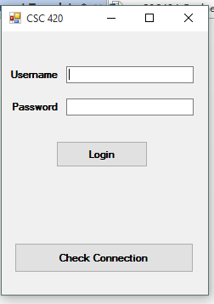

MAIN MENU WHERE YOU CAN CHOOSE MANY OPTIONS SUCH AS :

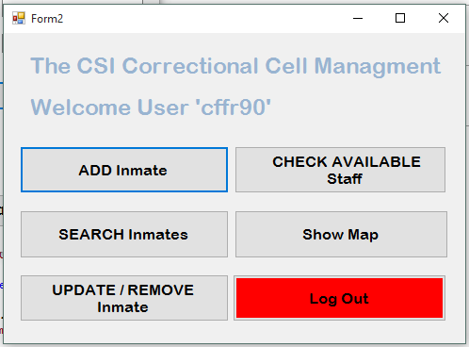

THIS FORM GIVES YOU THE OPTION TO INPUT AN INMATE

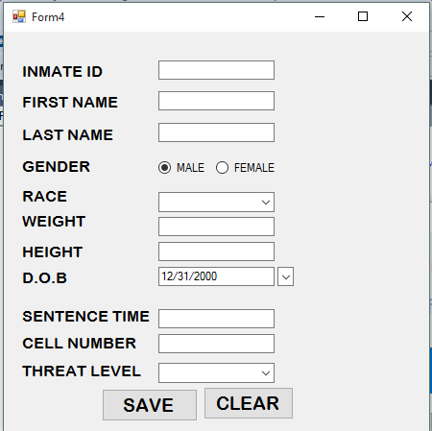

WINDOWS FORM WHERE YOU COULD SEARCH FOR INMATES

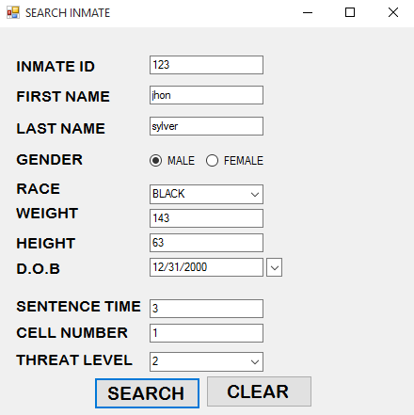

WINDOWS FORM WHERE YOU COUYLD SEARCH AND UPDATE INMATE

WINDOWS FORM TO UPDATE SEARCH STAFF MEMEBER

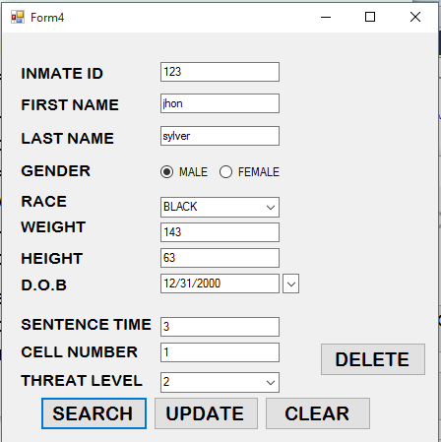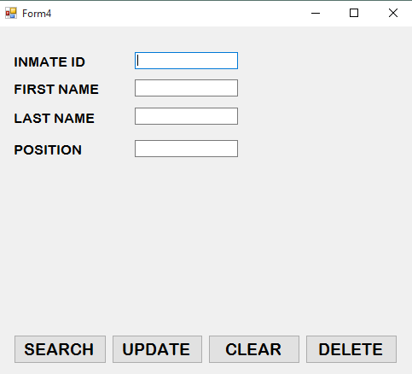

WONDOWS FORM THAT SHOWS A MAP OF THE INMATES

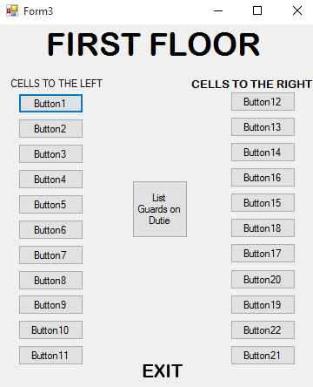

**5. References**

A complete tutorial playlist from Gnana Murthy A

Link : https://www.youtube.com/user/visualbasic6gnana

**6. Appendix**

1Introductiont to the project

2 Architecture design of the project

3 Database Design

3.1ER diagram

3.2relational data model

3.3logical schemas

4 GUI : Graphical user interface

5 References shows links of the research done in this project

6 Appendix

1. You can use your own font, font style, font color… The document is not double-spaced.